Field 2

comer

Player 073

Player 035

Cuando era*

niño/a . . .

En la escuela

elemental . . .

Durante la vacación . . .

Cuando tenía*

(5) años . . .

Muchas veces. . .

Mientras . . .

estudiar

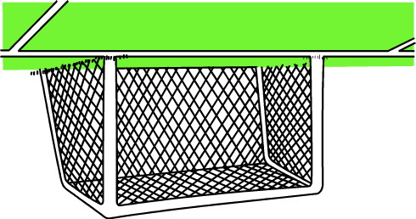

Goal

hablar

escribir

leer

ir a

A las 7

de la noche. . .

. . . cuando . . .

(interruption)

libreBall 28libre

Anoche . . .

Ayer. . .

Una vez . . .

Hace

una semana . . .

ir a

leer

escribir

estudiar

comer

hablar

Field 2

Player 073

Player 035

Cuando era*

niño/a . . .

En la escuela

elemental . . .

Durante la vacación . . .

Cuando tenía*

(5) años . . .

Muchas veces. . .

Mientras . . .



Goal

A las 7

de la noche. . .

. . . cuando . . .

(interruption)

libreBall 28libre

Anoche . . .

Ayer. . .

Una vez . . .

Hace

una semana . . .

**durante la semana**

**todos los días**

**por la mañana**

**por la noche**

**por la tarde**

**durante el fin de semana**

**a las ___ (8)**

**antes de la escuela**

**después de la escuela**

**es importante que**

**es necesario que**

**es imperativo que**

**es escencial que**

**ójala que**

**quizás**

**yo quiero que**

**recomiendo que**

**sugiero que**

**cómo se dice**

**qué significa**

Talking Football

**Skills to practice:**

Can be used to practice any language skill communicatively.

**Class Levels:** Adaptable for all levels of students and all class sizes.

**Requirements:**  Cut out the game resources below. Cut out the balls or players and use as markers. You may want to photocopy the game on A3 and laminate it.

**How to play:**

1. Prepare a list of **Main Texts** you want to practice. For example if you want to practice making sentences using the simple past tense, choose a number of verbs as your **Main Text** .(For example, **read, eat, go, dance, visit** etc.) Type in the **Main Text** in the spaces. Also prepare a set of Cue Text. Cue Texts combine with main texts to build sentences. For example in practising simple past tense the Main Texts could be the verbs and the Time adverbials the Cue Text. For example Verb = **watched** , Time adverbial = **Yesterday**. The student should combine both words in a sentence as such: **Yesterday** I **watched** a football match.
2. Students are expected to combine the Main Texts with the Cue Texts at the side to make sentences.
3. The two teams or players would toss a coin to decide who starts first, or do Rocks, Paper and Scissors. The winner starts combining a cue word and a key word to make sentences. For example **Last summer** + **visit**

**Last summer I visited my grandma.**

1. Everytime a student successfully combines a Cue Text with a Main Text, they move to the next word. Each time they land on a Main text, they should use a different Cue Text to make a sentence.
2. Both teams (players) keep advancing until they meet on their way in the same space. When they meet they do ROCKS, PAPER and SCISSORS. The team that looses the ROCKS, PAPER & SCISSORS duel goes back to restarts from his or her end. The winning side continues until they meet again. Every time they, meet they do rocks, paper, and scissors to see who wins. The team that gets to the other team’s goal first, wins.
3. When players get to the centre, it is a FREE space so they can create any sentence they like.

Football Game equipment

World Cup - France

Player 035

***Player A***

World Cup - England

World Cup - Belgium

World Cup - Cameroon

Player 073

***Player B***

World Cup - Italy

World Cup - Argentina